You are going to use faker and fs modules for this assignment. Create a project folder for EX2 and install all the dependencies. You can install all the modules at once by

npm install express body-parser faker fs –save

You should also create a package.json file. Once you declare the modules and set up your path to the directory, you are ready to code:

**Part I:**

You will write a simple loop to create 1000 fake first names, lasts names, etc. as shown below:

Martin Heathcote 60046-2114 Teresa79@yahoo.com Regional Integration Director (480) 695-1401 x93090

Harmon Kulas 57648-3046 Godfrey91@yahoo.com Global Infrastructure Engineer 009-966-4482

Alvena Lehner 67677 Rachel_Johnson@yahoo.com Legacy Directives Officer 1-252-506-8555 x90034

Viviane Cummings 83263 Monica69@hotmail.com Central Factors Specialist 1-077-969-6462

……

Look up faker module and its methods at <https://www.npmjs.com/package/faker>

Once the names are created, you will write all the data to a file called data.txt using writeFile function of the fs module. You can look up how to write to a file at <https://stackabuse.com/writing-to-files-in-node-js/> . The file will be automatically saved in your directory.

**Part II:**

This part populates a form with fake data when the user clicks on the generate button. You may want to create your form as shown below in a text editor before you bring it to your index.js. You should also style the form with your choice of styles. The form looks like: 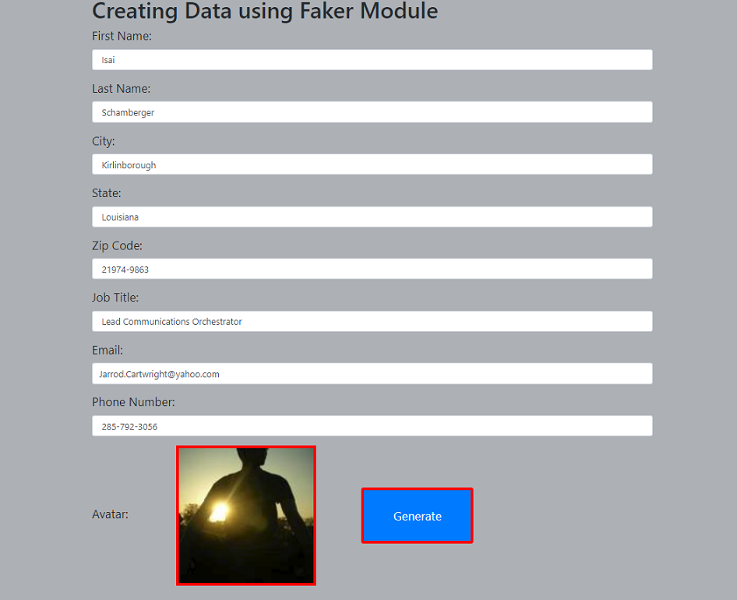

How do you populate your form with the faker’s data? Collaborate with each other and try to figure it out. This link could be useful: <https://www.npmjs.com/package/faker>

You should have comments that include your name, date, etc. Answer the following questions:

**Part III:**

1. What is a fs module? What it is used for in nodejs?

The fs module is the file system module that lets you work with your computer’s file system. It an read, create, delete, update, and rename files.

2. Write a line of code to open a file and print a message, “file is open successfully”.

var fs = require(‘fs’);

fs.open(file.txt', 'r', function(err, fd) {

if (err) {

return console.error(‘oops!’ + err);

}

console.log(‘file is opened successfully’);

});

3. Write a line of code that will tell you the type of a file that you are processing.

var path = require(‘path’);

path.extname(‘file.ext’);

4. Name at least 4 different methods for the fs module.

fs.readFile(); fs.readStream(); fs.readFileSync(); fs.writeFile();

5. Create four diff variables to store faker company name, state abbreviation, password and street

address.

var fCName = faker.company.companyName();

var fState = faker.address.state();

var fPassword = faker.internet.password();

var fAddress = faker.address.streetAddress();